**Lab 3—Rock cycle and plate tectonics**

Minerals are the building blocks that make up rocks. Rocks are grouped into three categories, determined by the way the rocks were formed: igneous, metamorphic, and sedimentary. Rocks are then identified by the minerals they are made up and the way in which they were formed.

THE ROCK CYCLE

The formation of these three categories of rocks can be thought of as occurring in a cycle. In this cycle, magma comes up from the mantle of the earth. It either cools inside the crust to form intrusive igneous rocks or exits by volcanoes to cool on the surface, resulting in extrusive igneous rocks. Igneous rocks and sedimentary rocks can be buried deep within the crust, and then through exposure to high temperatures and pressures, they change physically and chemically into metamorphic rocks. Rocks from all three categories can be broken down by weathering processes, transported, redeposited, and then formed into sedimentary rocks.

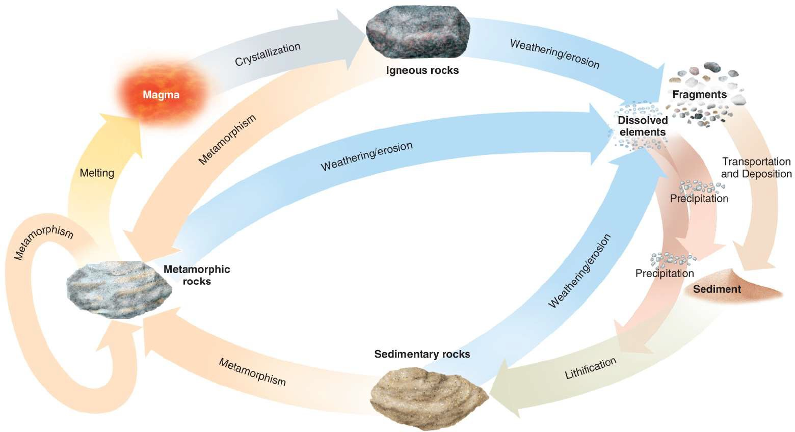

FIGURE 3.1 THE ROCK CYCLE

STRUCTURE OF THE EARTH

Our earth can be thought of as spherical, consisting of three major concentric layers from outside to the center: the crust, the mantle, and the core. These layers are further subdivided according to their composition and physical behaviors. The earth’s crust, both the oceanic and continental crust are made up of the rocks described above in the rock cycle. The boundary between the crust and the mantle, also known as the Moho, is defined by a change in the way that earthquake waves propagate through those materials. The uppermost mantle is solid; it moves in tectonic plates with the crust, and the two together are called the lithosphere. The lithospheric plates ride on the viscous asthenosphere, or lower mantle. The convection currents in the asthenosphere drive the process of plate tectonics. Below the mantle is earth’s core, consisting predominantly of iron and nickel: a solid inner core surrounded by a liquid outer core. It is believed that the convection of the liquid metal outer core induces the earth’s magnetic field.

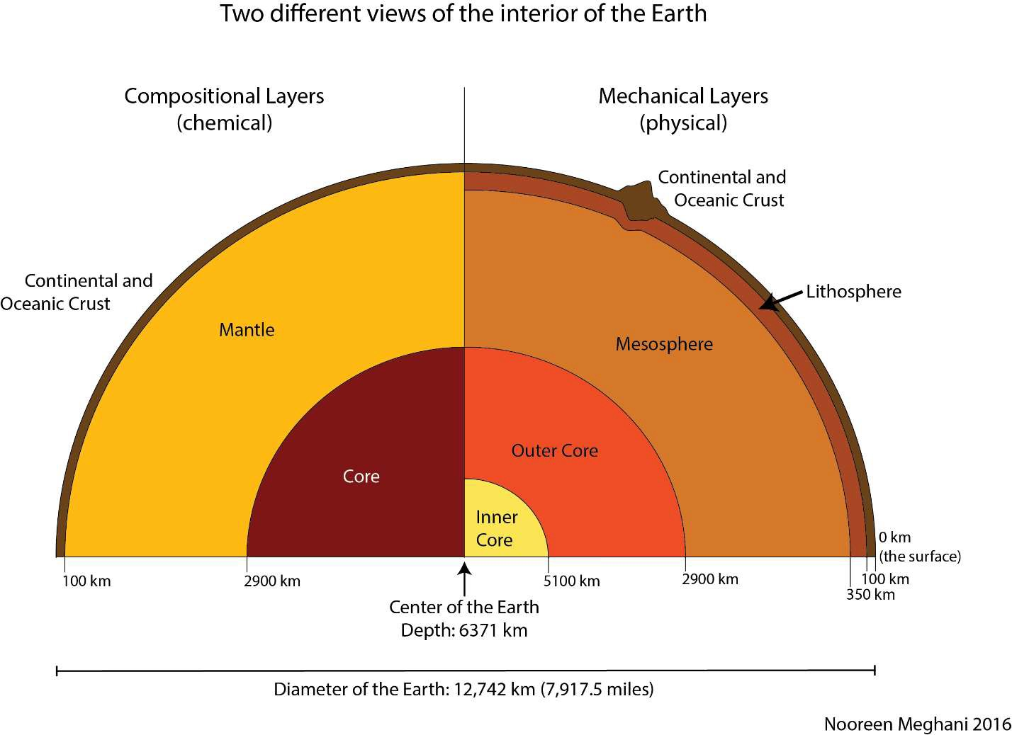

FIGURE 3.2 EARTH’S LAYERS (MEGHANI, 2016)

PLATE TECTONICS

Alfred Wegener is widely recognized as the first person to put forth, in 1929, the concept of continental drift that would serve as the basis for the theory of plate tectonics. He wrote: “The forces which displace continents are the same as those which produce great fold-mountain ranges. Continental drift, faults and compressions, earthquakes, volcanicity, transgression cycles, and polar wondering are undoubtedly connected causally on a grand scale. Their common intensification in certain periods of the earth’s history shows this to be true. However, what is cause and what effect, only the future will unveil.”

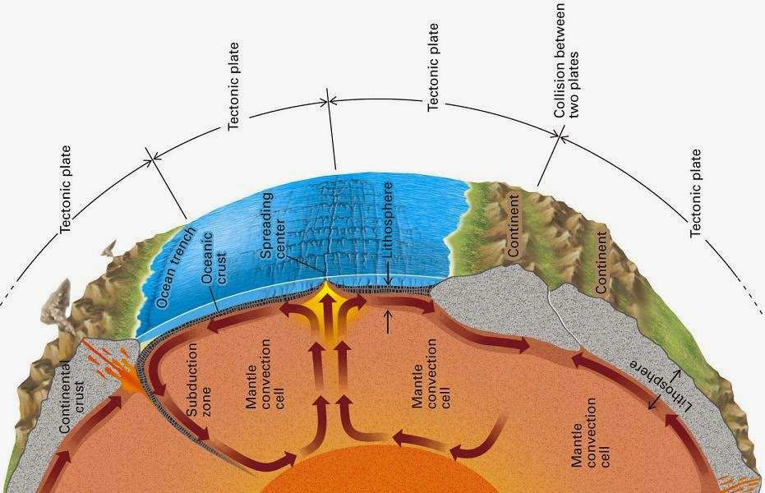With advances in technology and increased understanding about the way that earth’s magnetic orientation changes periodically, bands of oceanic crust were discovered with alternating magnetic alignments, creating stripes as it were, symmetrically about the mid-ocean ridges. The creation of new oceanic crust at these oceanic crust centers must be balanced by destruction of old crust. Thus, the driving force of mantle convection was deduced.

FIGURE 3.3 MANTLE CONVECTION AND ITS RELATION TO PLATE TECTONICS

Together, this mantle convection and the observation that the earth’s continents appear to fit like puzzle pieces fomented a scientific revolution. Plate tectonics emerged as a dominant geologic theory in the mid-twentieth century.

“The Himalayas are the crowning achievement of the Indo-Australian plate. India in the Oligocene crashed head on into Tibet, hit so hard that it not only folded and buckled the plate boundaries but also plowed into the newly created Tibetan plateau and drove the Himalayas five and a half miles into the sky. The mountains are in some trouble. India has not stopped pushing them, and they are still going up. Their height and volume are already so great they are beginning to melt in their own self-generated radioactive heat. When the climbers in 1953 planted their flags on the highest mountain, they set them in snow over the skeletons of creatures that had lived in a warm clear ocean that India, moving north, blanked out. Possibly as much as 20,000 feet below the sea floor, the skeletal remains had turned into rock. This one fact is a treatise in itself on the movements of the surface of the earth. If by some fiat, I had to restrict all this writing to one sentence; this is the one I would choose: the summit of Mount Everest is marine limestone.”

* John McPhee, Annals of the Former World

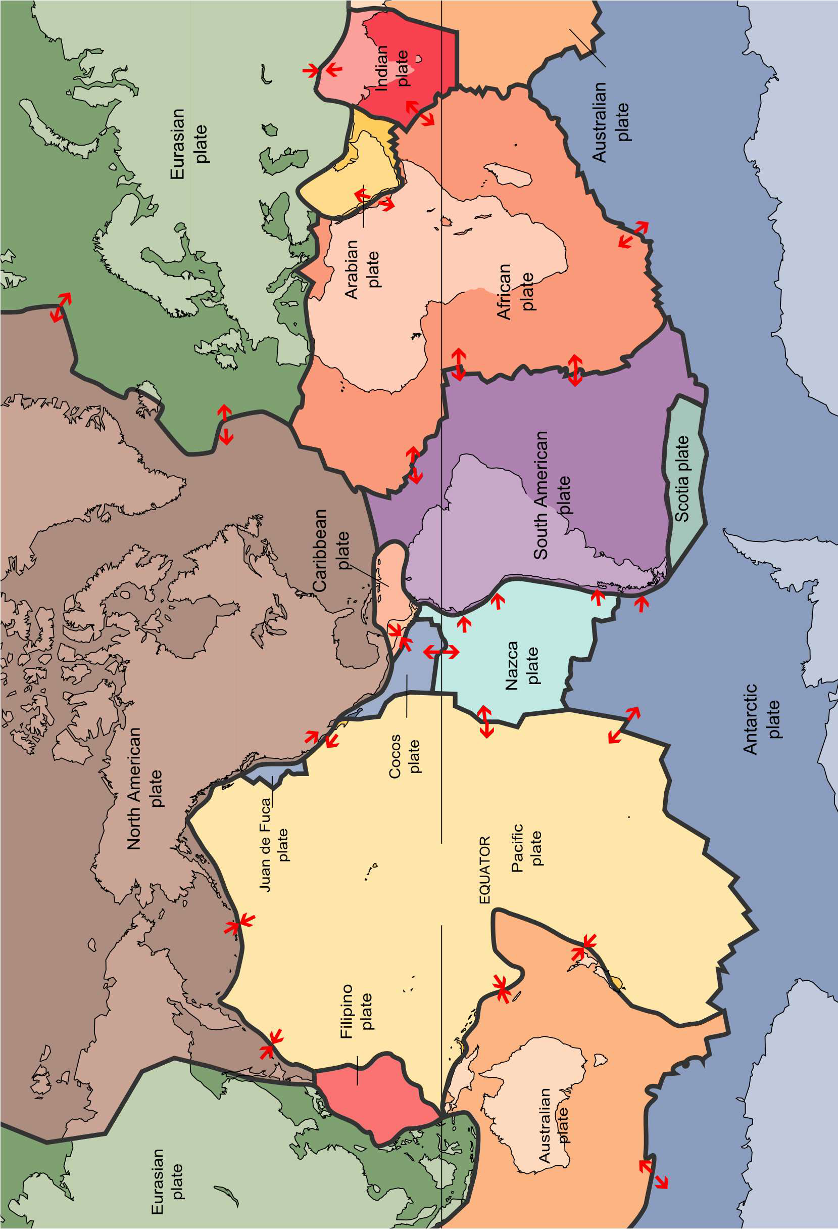

FIGURE 3.4 TECTONIC PLATES (NASH, 1996)

Lab Questions for The Rock Cycle and Plate Tectonics

*A Closer Look at the Rock Cycle*

1. Examine the igneous, sedimentary and metamorphic rock samples provided. Discuss with your classmates some of the similarities and differences between the three rock types. Then, discuss some of the processes that lead to the formation of each rock type.

1a) List at least one characteristic that makes each rock type distinctive. Conversely, what is similar about all three rock types?

1b) List at least 1 process each that could lead to the formation of an igneous rock, a sedimentary rock, and a metamorphic rock.

*Density of Earth’s Crust*

The Earth’s crust can be divided into two categories: Oceanic and Continental.

* + **Continental crust** is composed primarily of **granite**
  + **Oceanic crust** is composed primarily of **basalt**

Though both granite and basalt are considered igneous rocks, they have different elemental compositions. Basalt is *slightly* more enriched in iron, magnesium, and nickel than granite, which has oxygen, aluminum, and silicon. (Take a look at the periodic table in the back of this manual to determine which of these elements are denser than others.)

1. Look at the samples of granite and basalt provided. Note your observations about each type of rock.

**Granite**

**Basalt**

1. Scientific hypothesis: Which of these two rocks do you think is denser?
2. Test with Experimentation: Calculate the density of 2 basalt and 2 granite samples using the equation, $ρ=m/V$ and filling in the chart below. Mass is provided for each sample, but you will have to calculate volume using a water displacement method. Recall that for water, 1 mL = 1 cm3.

|  |  |  |  |
| --- | --- | --- | --- |
| **Sample name/Rock type** | **Mass** ($m$, g) | **Volume** ($V$, mL) | **Density** ($ρ=m/V, {\text{g}}/{{\text{cm}}^{\text{3}}}$) |
|  |  |  |  |
|  |  |  |  |
|  |  |  |  |
|  |  |  |  |

1. Analyze the results and draw a conclusion based on your experiment above. Was your hypothesis correct?
2. Communicate with your classmates to compare results. Are your calculated density measurements the same? If not, list 2 possible sources of error.

*P late Movement*

To answer these questions, view this [paleogeographic animation](https://drive.google.com/file/d/1DO1hNFPxbCs8r3IZ-ajuoljmH4ivSx_5/view) (<https://drive.google.com/file/d/1DO1hNFPxbCs8r3IZ-ajuoljmH4ivSx_5/view>),

that shows the paleogeography of the North Atlantic during the last 290 million years.

1. Can plate movement over time be best described as simple horizontal or vertical movements, as rotations, or both?
2. What type of plate margin was eastern North America during the early stages of plate movement?
3. In relation to North America, where was Africa located 250 million years ago?
4. Describe the continent of Africa’s subsequent movements.

Age of the Oceanic Crust (refer to Figure 3.5)

1. What color represents the youngest oceanic crust? What color represents the oldest oceanic crust?
2. What kind of boundary is associated with the youngest oceanic crust? How is crust formed at this type of boundary?
3. Looking at the small Philippine plate (be sure you’re looking at the thin arrow, not the thick arrow):

7a) What type of boundary makes up the eastern border of the plate?

7b) What is the approximate age of the crust on the Pacific plate where it meets the Philippine plate?

7c) Is the Philippine plate subducting under the Pacific plate, or vice versa? 7d) Why does the one plate more readily subduct beneath another?

*Volcanoes Around the World* (refer to the Figure 3.6)

1. Do you see any relationship between the locations of volcanic chains and plate boundaries? Is this relationship specific to one type of plate boundary? Explain.
2. Does this relationship account for all volcanoes and volcanic island chains or do some follow a different trend? List two locations on the map where volcanoes/volcanic chains do not follow the trend. What, then, accounts for the locations of these volcanoes/chains?

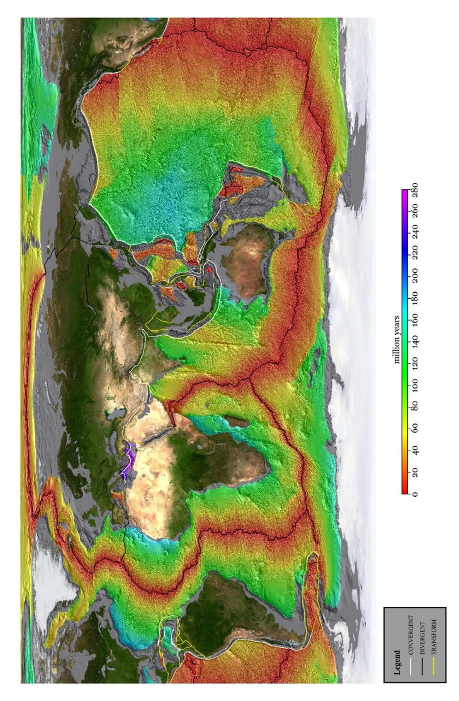

FIGURE 3.5 THE AGE OF EARTH’S OCEANIC CRUST (LIM, 2019)

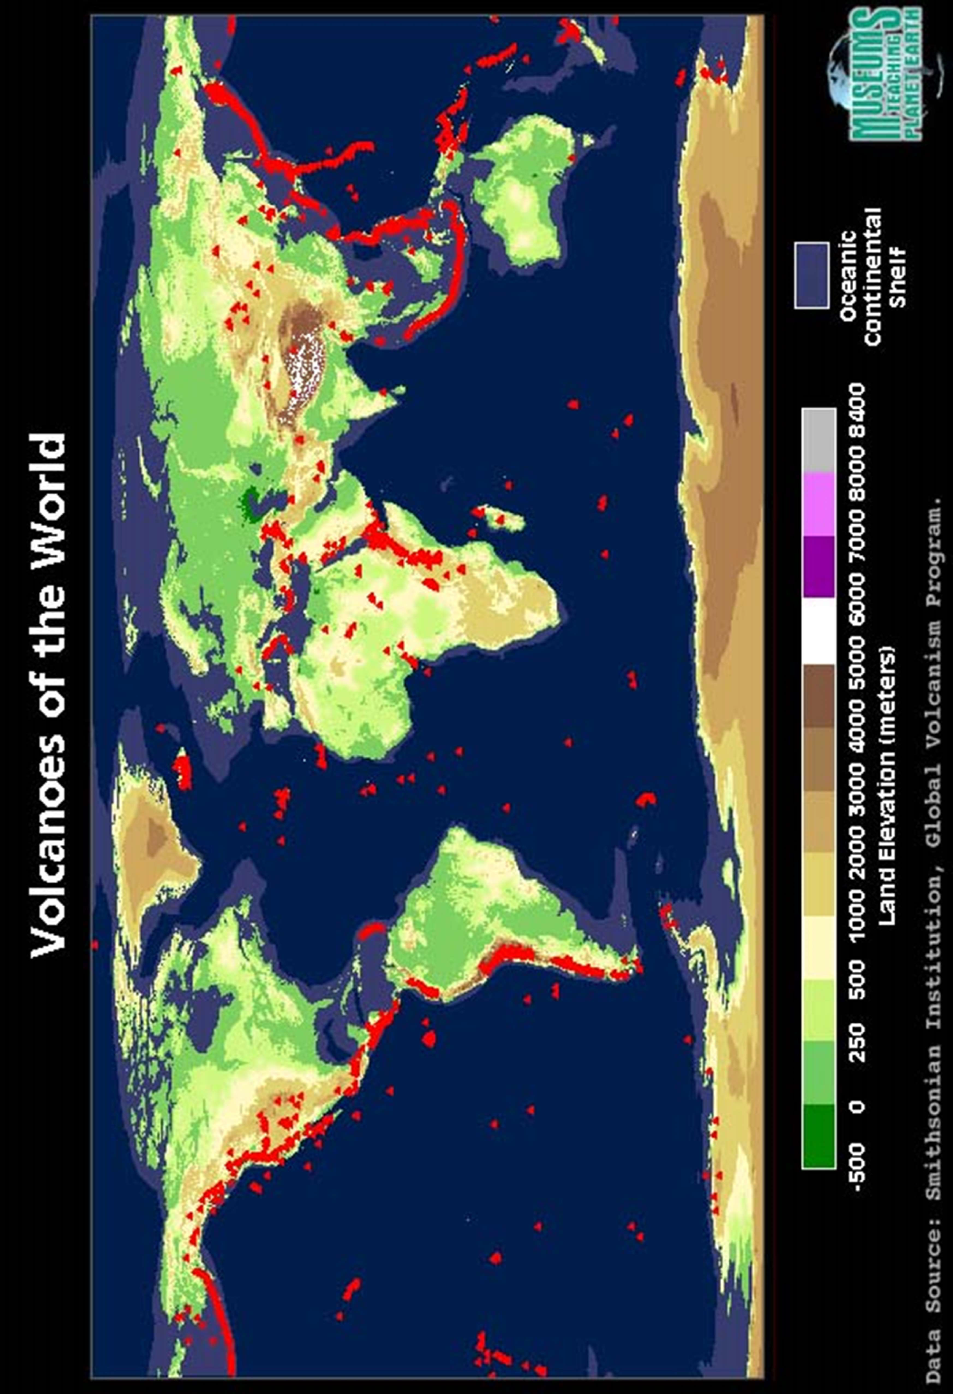

FIGURE 3.6 VOLCANOES OF THE WORLD (2019)

*Earthquakes Around the World* (refer to Figure 3.7)

1. Which colored circles represent the deepest earthquakes?
2. Do you see any patterns or trends in the location of earthquakes around the world?
3. What kind of plate boundaries are associated with shallower earthquakes? Deeper earthquakes?
4. The plate boundary between the Nazca Plate and the South American Plate is located just off the west coast of South America. Are the deepest earthquakes associated with this boundary located closer to the coast (and to the plate boundary), or further inland? How does this relate to the subduction of the Nazca Plate?

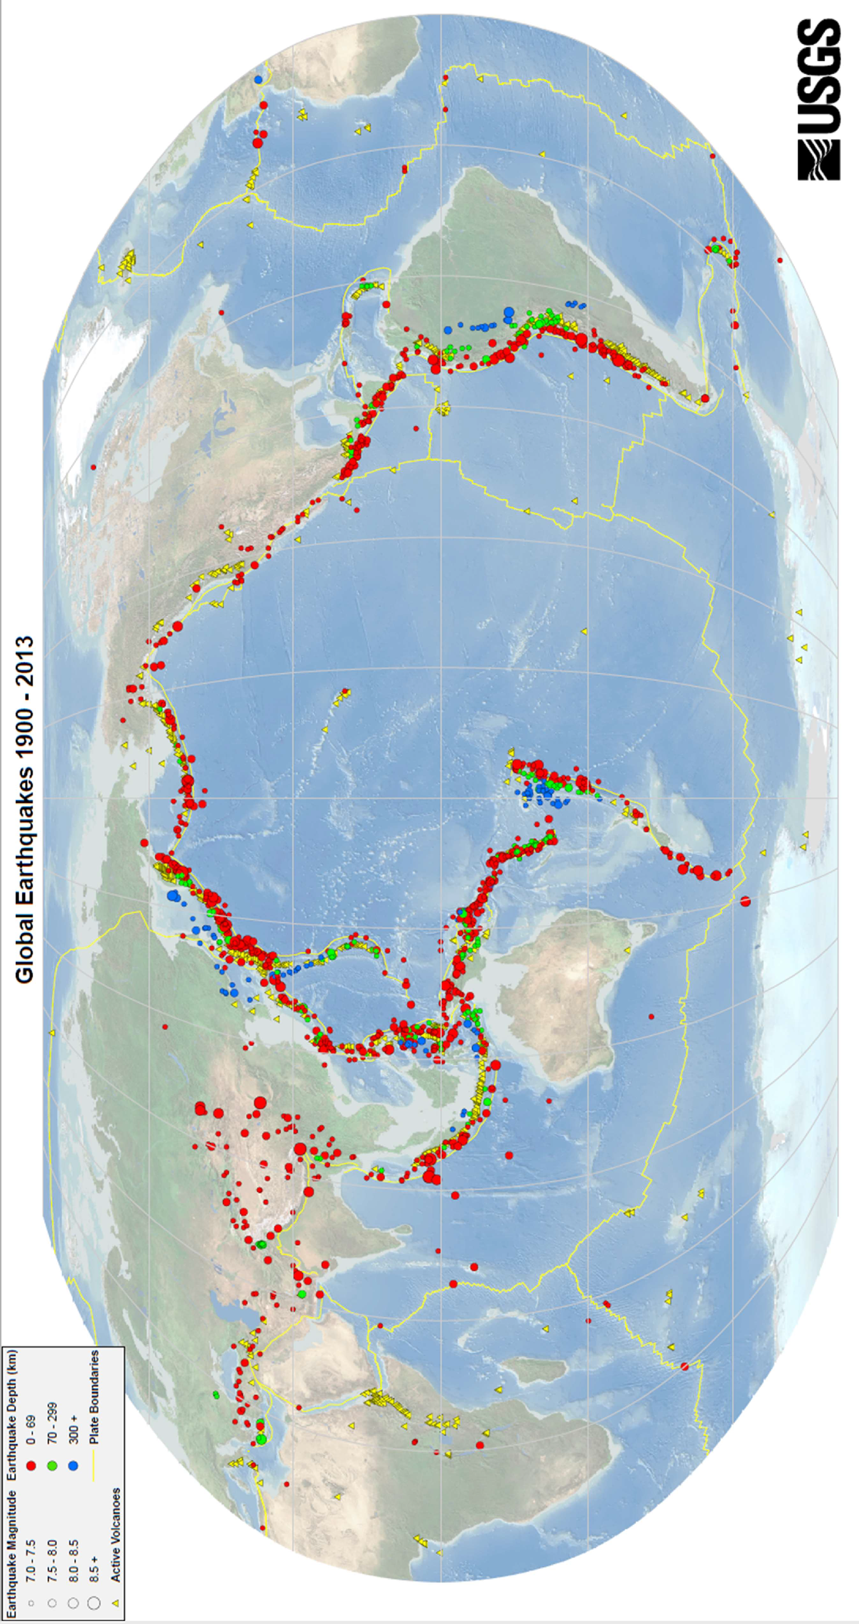

FIGURE 3.7 GLOBAL EARTHQUAKES (2019)

***Hawaii: An Oceanic Hotspot*** (refer to Figure 3.8)

(Questions from Busch and Tasa: Laboratory Manual in Physical Geology, Eighth Edition, 2009) The associated figure shows the distribution of the Hawaiian Island Chain and Emperor Seamount Chain. The numbers indicate the age of each island in millions of years (m.y.), obtained from the basaltic igneous rock of which each island is composed.

1. What is the rate in cm/yr. and direction of plate motion from 4.7-1.6 million years ago?
2. What is the rate in cm/yr. and direction of plate motion from 1.6 million years ago to present time?
3. How does the rate and direction of Pacific Plate movement during the past 1.6 million years differ from the older rate and direction (4.7-1.6 m.y.) of plate motion?
4. Locate the Hawaiian Island Chain and the Emperor Seamount Chain in the upper part of the image. How are the two island chains related?
5. Based on the distribution of the Hawaiian Islands and Emperor Seamount chains, suggest how the direction of the Pacific plate movement has generally changed over the past 60 million years.

For the following questions, reading the information at this site

(https://volcanoes.usgs.gov/observatories/hvo/about_earthquakes.html).

1. Are earthquakes common on the island of Hawaii? Are low magnitude or high magnitude quakes most common?
2. What are the types of Hawaiian earthquakes? Provide a brief summary of each.
3. Do you think earthquakes are as common on other islands in the Hawaiian island chain? Explain.

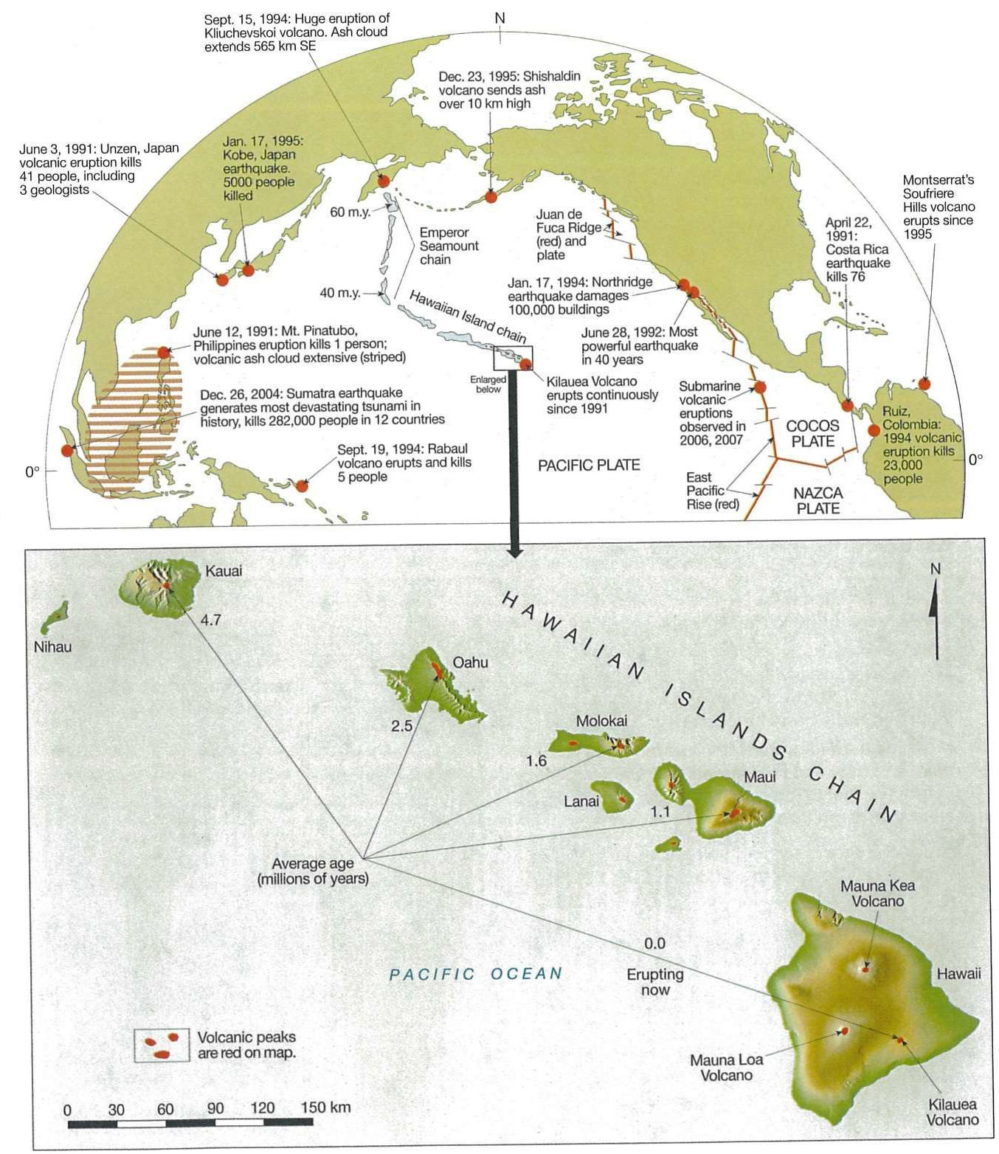

FIGURE 3.8 HAWAIIAN ISLANDS CHAIN

***Yellowstone: A Continental Hotspot*** (refer to Figure 3.9)

(Questions from Busch and Tasa: Laboratory Manual in Physical Geology, Eighth Edition, 2009) Another good example of a hotspot is Yellowstone National Park. Although there are no volcanoes currently erupting in Yellowstone today, there are hot springs and geysers. Geologist Mark Anders has been able to reconstruct a map of circular regions that were once centered over the hotspot at specific times.

1. Based on the ages and location of each Yellowstone Hot Spot Deformation Zone, what direction is the North American Plate moving?
2. What is the average rate in cm/yr. that the North American Plate has moved over the past 11 million years?

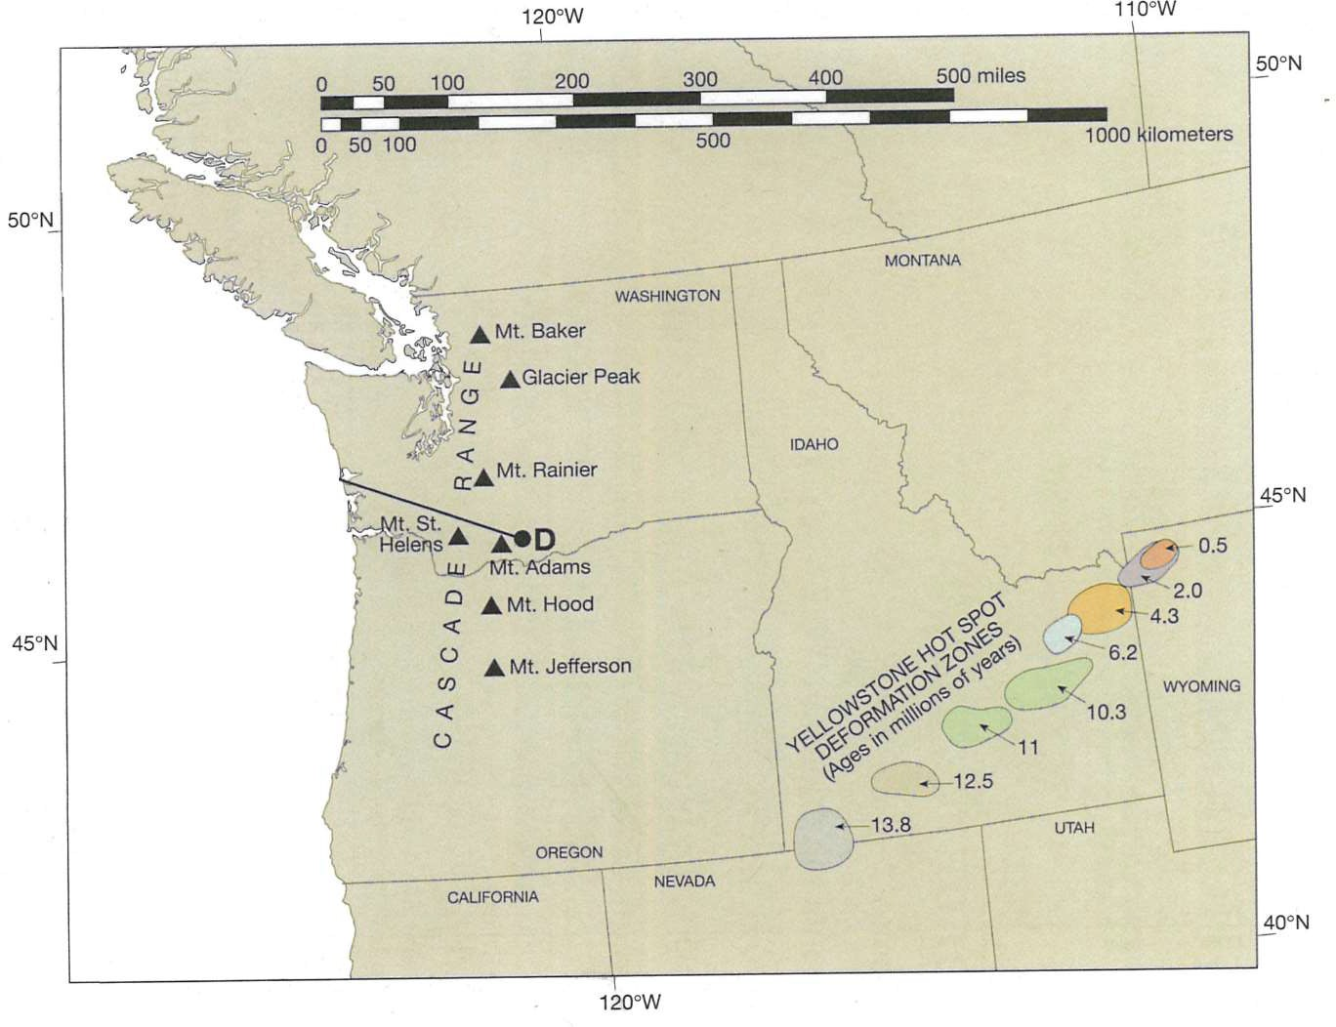

FIGURE 3.9 TRACK OF THE YELLOWSTONE HOT SPOT

NOTES

NOTES